For immediate Release
August 12, 2014
Media Contact:
Laura Schairer
480-797-3111
laura@audiencemagnets.com

ARIZONA OPERA OPENS SEASON WITH
CRUZAR LA CARA DE LA LUNA
(TO CROSS THE FACE OF THE MOON)

First mariachi opera features world renowned Mariachi Vargas

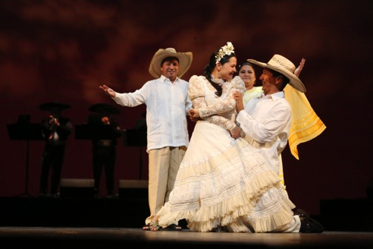

(Phoenix, Ariz) Arizona Opera brings the world's first mariachi opera to the stage as it kicks off its 2014-2015 Season. Cruzar la Cara de la Luna has become a smash sensation around the globe, blending the passion and artistry of mariachi with the emotionally touching story of a Mexican immigrant family. Commissioned in celebration of the anniversaries of Mexican Independence and Revolution, Cruzar la Cara de la Luna features the legendary Mariachi Vargas de Tecalitlán and promises to be an unforgettable night of raw energy, drama and virtuosity.

With music written by Jose "Pepe" Martinez, Mariachi Vargas Music Director and books and lyrics by Leonard Foglia, Cruzar la Cara de la Luna will be performed October 10th and 11th at 7:30, October 12th at 2:00 pm in Symphony Hall in Phoenix and October 18that 7:30 and October 19th at 2:00 pm in the Tucson Music Hall in Tucson.

Cruzar la Cara de la Luna is sung in Spanish and English with English supertitles.

In the week leading up to the performances, Arizona Opera will host a Hispanic Heritage Festival October 6 - 11 in Phoenix and Oct 13 - 19 in Tucson including demonstrations, mariachi and folklorico performances, lectures and family events. (See detailed schedule below.)

About Cruzar la Cara de La Luna by Leonard Foglia
Where is home? Is it where we are born? Or where we live most of our lives? Is it with the family we leave behind or with the new ones we create?

To Cross the Face of the Moon / Cruzar la Cara de la Luna follows three generations of a single family, divided by countries and cultures. As a Mexican/American man deals with the approaching death of his father, he is forced to face these questions about his own place in the world - straddling two cultures - as well as that of his immigrant father and his American daughter. As long buried secrets are revealed, he finds himself dramatically re-evaluating his own understanding of what makes a family. Like the Monarch butterflies that migrate every year to the birthplace of his father, the members of the Velasquez family must travel both physically and spiritually between Michoacán and Texas and look deep into their hearts before they learn where they truly belong.

CRUZAR LA CARA DE LA LUNA
Music by José "Pepe" Martínez
Lyrics by José "Pepe" Martínez and Leonard Foglia
Book by Leonard Foglia
An HGOco Production of Houston Grand Opera
Commissioned by Houston Grand Opera
Premiered at Houston Grand Opera in September 2010

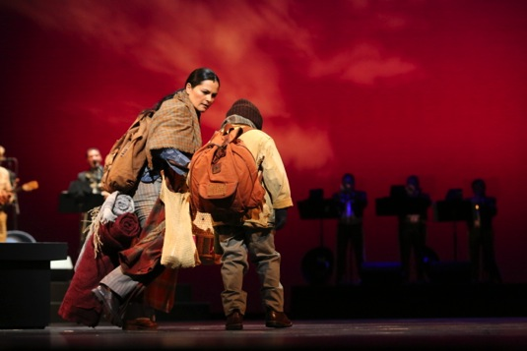

Cruzar la Cara de la Luna Participating Sponsors

Phoenix Performance Information
October 10 & 11 at 7:30pm; October 12 at 2:00pm
Symphony Hall
75 N. 2nd St., Phoenix, AZ 85004

Tucson Performance Information
October 18 at 7:30pm; October 19 at 2:30pm
Tucson Music Hall
260 S. Church St., Tucson, AZ 85719

Arrive one hour early to attend pre-performance lecture and stay after the performance to meet with cast and creative team to discuss the production.

Tickets: Tickets start at $25 and are on sale at www.azopera.org or by calling 602-266-7464 (Phx) or 520-293-4336 (Tuc)

CAST & CREATIVES
Mariachi Vargas de Tecalitlán Music Director  Stage Director  Choreographer  Laurentino  Renata  Mark  Diana  Rafael  Lupita  Chucho  Victor  Young Rafael | José "Pepe" Martínez  Leonard Foglia  Keturah Stickann  Octavio Moreno  Cecilia Duarte  Brian Shircliffe  Brittany Wheeler  David Guzman  Vanessa Cerda-Alonzo  Saúl Ávalos  Juan Mejia  Rodrigo de Leon Bran
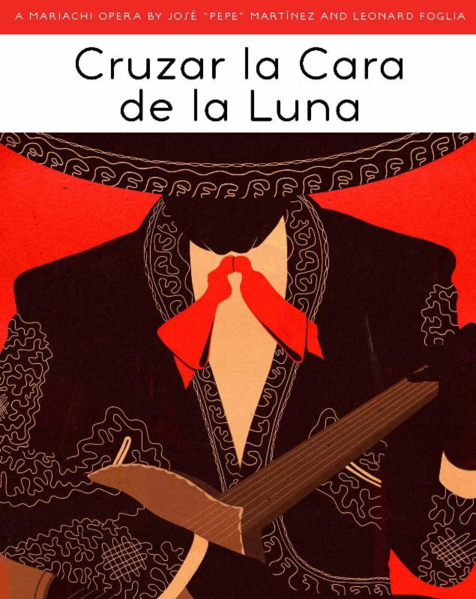

HISPANIC HERITAGE FESTIVAL
PHOENIX OCTOBER 6 - 11
TUCSON OCTOBER 13- 19

Sponsored by and

In conjunction of this groundbreaking new work, Arizona Opera is presenting a Hispanic Heritage Festival in the weeks leading up to performances. During these weeks, the Arizona Opera will be facilitating conversation, providing demonstrations, and hosting celebrations of Hispanic culture. We will be bringing together different members of our community to celebrate our cultural differences in order to find the common ground that unites us all.

The Borders of Understanding
October 6 at 6:00 pm, Carnegie Library 1101 W Washington St, Phoenix, AZ
October 13 at 6:00 pm, Tucson Museum of Art, 140 N Main Ave, Tucson, AZ 85701

Three local scholars and community leaders will partake in a guided conversation about the current state of immigration and how the arts are uniquely positioned to promote cultural understanding. This discussion will be moderated by documentary-filmmaker and Governor's Arts Award-winner, Daniel Buckley.

Mariachi: The Passion and Pulse of a People
October 7 at 6:00 pm, Arizona Opera Center 1636 N. Central Ave, Phoenix AZ 85004
October 14 at 6:00 pm, Leo Rich Theater 260 S. Church, Tucson, AZ 85719
During this lecture demonstration, you will be treated to an exploration of mariachi by leading mariachi scholars and performers. This educational event will be fun and energetic as music and conversation collide.

The Cultural Exchange
October 8 at 6:00 pm, Arizona Opera Center 1636 N. Central Ave, Phoenix AZ 85004
October 16 at 6:00 pm, Leo Rich Theater 260 S. Church, Tucson, AZ 85719
On this special night, the Arizona Opera will be converted into a marketplace! Our doors will be wide open and music will fill the air as people survey Mexican cuisine provided by local food trucks, buy arts and crafts from local artisans, and enjoy performances by Mariachi and folklorico groups.

Student Night
Sponsored by and
October 9 at 7:00 pm, Symphony Hall, 75 N. 2nd St, Phoenix AZ 85004
Generously underwritten by JP Morgan Chase and Blue Cross Blue Shield this exciting night fills Symphony Hall with local school children who will experience the final dress rehearsal of Cruzar la Cara de la Luna. (Contact the Arizona Opera Education Department for reservations.)

Connecting the Dots: A Demonstration of Hispanic Art
October 11 from 12:00 to 2:00 pm Arizona Opera Center 1636 N. Central Ave, Phoenix AZ 85004
During the day, participants can come to the Opera Center for a teaching demonstration of Hispanic crafts. Participants will learn how mariachi costumes are made, mariachi songs are written, and Mexican art is produced before experiencing the Saturday performance of Cruzar la Cara de la Luna.

Spanish Music-Up Close
October 15 at 6:00 pm, Leo Rich Theater 260 S. Church, Tucson AZ 85719
Arizona Opera presents a masterclass with the Arizona Opera Studio Artists as a special addition to our Tucson Festival. The Studio Artists will perform and hone Hispanic songs and Spanish arias with local expert, Greta Skelly.

Student Night at the Opera
Sponsored by
October 17 at 7:00 pm, Tucson Music Hall, 260 S. Church, Tucson AZ 85719
Generously underwritten by JP Morgan Chase, this exciting night will fill the Tucson Music Hall with local school children who will experience the final dress rehearsal of Cruzar la Cara de la Luna. (Contact the Arizona Opera Education Department for reservations.)

Cruzar la Cara de la Luna - A Mariachi Opera
PHX: October 10 & 11 at 7:30, October 12 at 2:00 pm
Symphony Hall 75 N. 2nd St, Phoenix AZ 85004
TUC: October 18 at 7:30, October 19 at 2:00 pm
Tucson Music Hall 260 S. Church, Tucson AZ 85719
An electrifying season opens as Arizona Opera brings the world's first mariachi opera to the stage. Cruzar la Cara de la Luna has become a smash sensation around the globe, blending the passion and artistry of mariachi with the emotionally touching story of a Mexican immigrant family. Commissioned in celebration of the anniversaries of Mexican Independence and Revolution, Cruzar la Cara de la Luna features the legendary Mariachi Vargas de Tecalitlán and promises to be an unforgettable night of raw energy, drama and virtuosity.

Arrive early to get into the mood by listening to local mariachi playing outside of the theater, and attend an informal lecture before and after the performance.

About Arizona Opera
Arizona Opera, now in its 44th season, is our state's only professional opera company that produces fully-staged opera performances, concerts, in-school touring productions, educational and outreach programs that reach over 70,000 school-children and adults annually. Since its inception, Arizona Opera has produced over 180 fully-staged operas and concerts. The company's artistic history is rich with a blend of opera's traditional repertoire featuring baroque, bel canto, and verismo works, turn-of-the-century masterpieces, operettas, and American operas. Arizona Opera has also presented Wagner's complete Ring Cycle twice, a feat that has been accomplished in North America by only five other companies. Founded in 1971, Arizona Opera is among only a handful of companies in the United States that regularly performs in more than one city.
Arizona Opera’s 2014-15 Season is presented by

